Name : …
ENG104L 002 Winter 2020
Date : …

- Subject
Basically, just a one line title of the experiment.

- Purpose
What is the objective of the experiment? Why did we break the rod? 2-3 lines or 2-3 bullet points

- Procedure
Summarize the whole procedure in not more than 5 bullet points. You can copy the lab manual but please provide reference as (ENG104L lab manual).

- Sample Calculations
Provide me with one calculation for the following:
- Calculate the Area of the rod
- Calculate the stress for one of the force readings (say 4000 strain on first loading)
- Calculate Young’s modulus
- Calculate Rebound modulus
State all the assumptions in the sample calculations clearly.
Use equation tool in Word to type the equation and sample calculation. The sample calculation should have units in every step, for example:
Area of a 2m x 2m square is:
$$Area=Length x Breadth$$
$$=2 m x 2 m$$
$$=4 m$$
Yes, it is boring and redundant, but this practice will save your ass when you work in industry.
- Results
This is an important section. All your results should be presented here, which include:
- Young’s modulus (slope of the initial elastic line)
- Rebound modulus (slope of the rebound line)
- Yield stress
- ε₀
- Ultimate load and ultimate stress
- Load at failure and stress at failure
- Value of the K parameter
- Value of the n parameter

- Discussions
This is the most important section which I will pay the most attention to.
- Please answer ALL the questions presented at the end of your manual
- Do not provide vague answers. Be to the point and try to answer the sub-questions in 2-3 lines.
- Do try to compare your results from results in literature and provide possible explanations to the deviation.
- Do not provide “HUMAN ERROR”, “INSTRUMENTAL ERROR”, “MECHANICAL ERROR” as probable cause of deviation. I am not going to provide any points for these answers.

- Summary
What did we do? 1-2 line
Why did we do? 1-2 line
What did you observe? 1-2 line
Any more comments? 1-2 line

- Attachments
All the graphs and excel sheet goes here. Graphs should have a caption at the bottom and excel table should have caption at the top. Please provide:
- Graph showing the overall response, the line showing various slopes (Young’s modulus, rebound modulus, 0.2% line for σy) and the points where you picked ε0 and σy.
- Graph showing the fitted curve on top of the original curve.
- Excel sheet snippet for your data. Make sure this is clean and visible while copying.
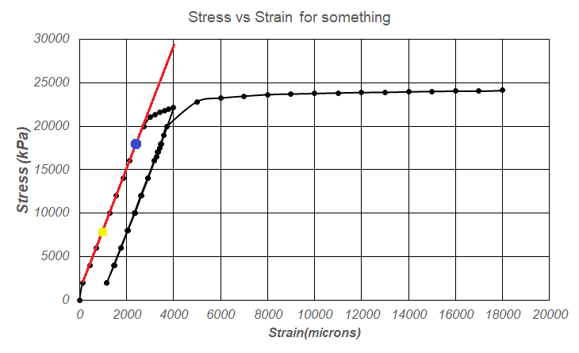
Figure 1 Stress strain plot for something, with red line denoting the initial elastic region. The Young's modulus is found between the points shown in blue and yellow.

- References
Add all the references you use for the discussion and the lab manual if you copy the purpose.

